Certified Backflow Testers
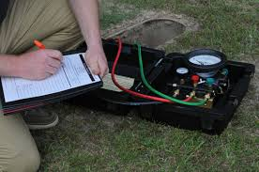
This list is provided solely for the convenience of our water customers, and does not represent endorsement or support by the City of Paific. Customers should use their own judgment and criteria when contracting with these or any other testers.
Disclaimer
The City of Pacific makes no representation regarding the abilities, performance, or quality of service of the testers listed below. Further, the City of Pacific does not assume or accept any responsibilities for the actions or performance of such testers. This list is provided only for the convenience of the water service customers. Customers are responsible for their own contracts with these or any other testers. Please also note that the following list is in alphabetical order and does not indicate any preference or preferred ranking.
Company | City | Phone
Affordable Backflow Tester | Renton | 206-369-6178
Auburn Mechanical | Auburn | 253-838-9780
Available Backflow Testers | Covington | 425-652-9970
Green Effects | Sumner | 253-606-3423
Olympic Landscape and Irrigation | Fife | 253-922-7075
Pat’s Plumbing | Federal Way | 800-491-4081
Smith Fire System Management | Tacoma | 253-248-2011

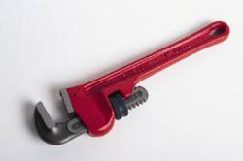
All Backflow Assembly Testers wishing to test within the City of Pacific will have to comply with the following:

- Have a City of Pacific Business License
- Copy of Department of Health annual BAT validation card
- Copy of insurance policy with the City of Pacific named as additionally insured.
- Copy of annual calibration of testing equipment.
- Testers must follow Washington State Department of Health test procedures.
- Assemblies must have test port plugs in areas subject to flooding.
- All test reports must be complete, legible, and accurate.

Failure to comply with any of the above could result in the test report being rejected, and sent back to the customer.

If you have any questions, contact Jim Schunke at (253) 929-1116, or e-mail jschunke@ci.pacific.wa.us

